ANDROID ASSIGNMENT 2

1. Create an app that shows a splash screen with an icon at the centre of the screen.

Splash Activity Design

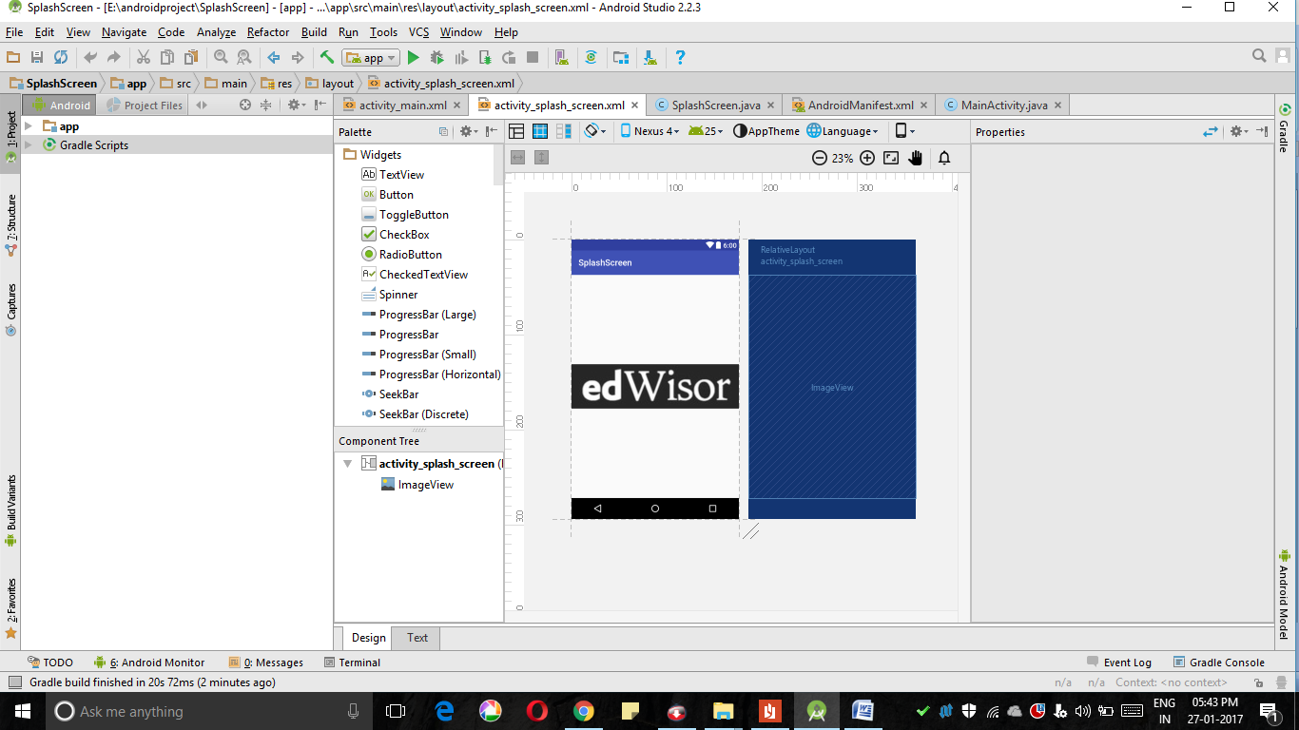

Splash activity.xml file

<?xml version="1.0" encoding="utf-8"?>  
<RelativeLayout xmlns:android="http://schemas.android.com/apk/res/android"  
 xmlns:tools="http://schemas.android.com/tools"  
 android:id="@+id/activity_splash_screen"  
 android:layout_width="match_parent"  
 android:layout_height="match_parent"  
 tools:context="com.edwisor.splashscreen.SplashScreen">  
<ImageView  
 android:layout_width="match_parent"  
 android:layout_height="match_parent"  
 android:src="@drawable/edwisorlogo"/>  
</RelativeLayout>

Java file for Splash activity

package com.edwisor.splashscreen;  
  
import android.content.Intent;  
import android.support.v7.app.AppCompatActivity;  
import android.os.Bundle;  
  
public class SplashScreen extends AppCompatActivity {  
  
 @Override  
 protected void onCreate(Bundle savedInstanceState) {  
 super.onCreate(savedInstanceState);  
 setContentView(R.layout.activity_splash_screen);  
 Thread myThread = new Thread(){  
 @Override  
 public void run() {  
 try {  
 sleep(3000);  
 Intent intent = new Intent(getApplicationContext(), MainActivity.class);  
 startActivity(intent);  
 finish();  
 } catch (InterruptedException e) {  
 e.printStackTrace();  
 }  
  
 }  
 };  
 myThread.start();  
 }  
}

Output

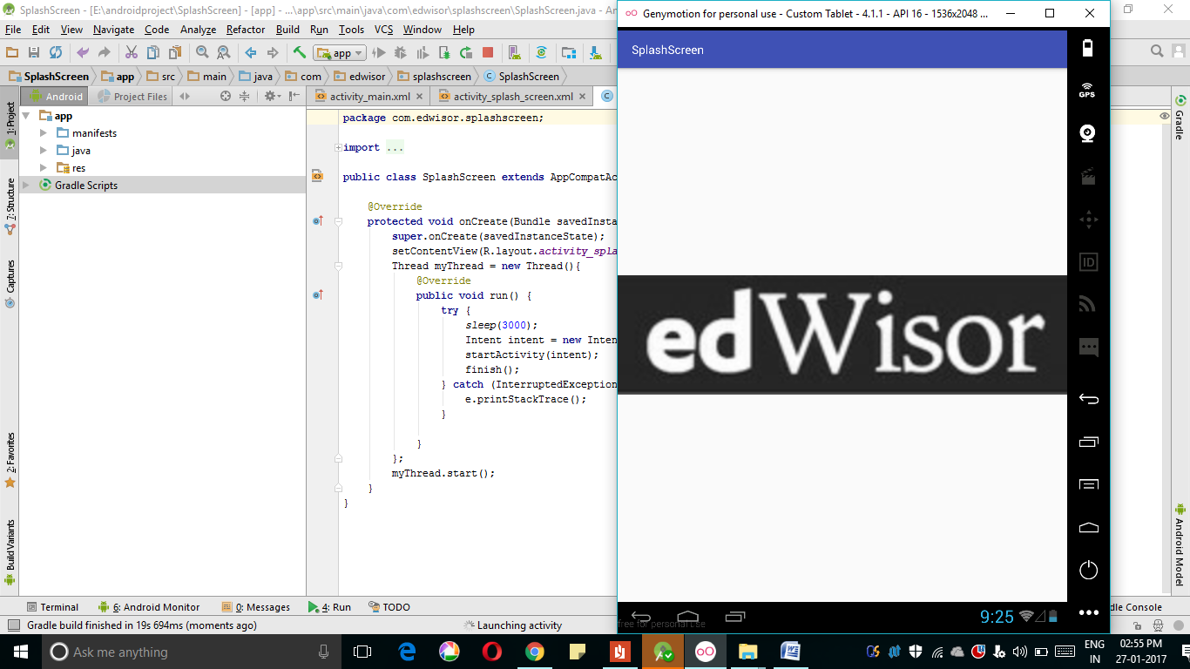

2. Create a logic screen which will only take user123@example.com as username and User@1234 as password.

Main login screen activity_main.xml design

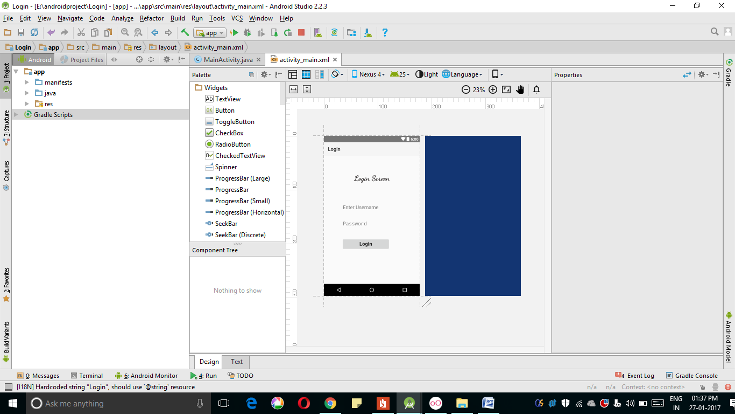

Main login screen activity_main.xml file code

<?xml version="1.0" encoding="utf-8"?>  
<RelativeLayout xmlns:android="http://schemas.android.com/apk/res/android"  
 xmlns:app="http://schemas.android.com/apk/res-auto"  
 xmlns:tools="http://schemas.android.com/tools"  
 android:id="@+id/activity_main"  
 android:layout_width="match_parent"  
 android:layout_height="match_parent"  
 android:paddingBottom="@dimen/activity_vertical_margin"  
 android:paddingLeft="@dimen/activity_horizontal_margin"  
 android:paddingRight="@dimen/activity_horizontal_margin"  
 android:paddingTop="@dimen/activity_vertical_margin"  
 tools:context="com.edwisor.login.MainActivity">  
  
 <EditText  
 android:layout_width="wrap_content"  
 android:layout_height="wrap_content"  
 android:inputType="text"  
 android:ems="10"  
 android:layout_alignParentTop="true"  
 android:layout_centerHorizontal="true"  
 android:layout_marginTop="167dp"  
 android:id="@+id/et_login_username"  
 android:textSize="20dp"  
 android:hint="Enter Username"  
 android:layout_marginBottom="20dp" />  
  
 <EditText  
 android:hint="Password"  
 android:layout_width="wrap_content"  
 android:layout_height="wrap_content"  
 android:inputType="textPassword"  
 android:ems="10"  
 android:textSize="20dp"  
 android:id="@+id/et_login_password"  
 android:layout_below="@+id/et_login_username"  
 android:layout_alignLeft="@+id/et_login_username"  
 android:layout_alignStart="@+id/et_login_username" />  
  
 <Button  
 android:text="Login"  
 android:textSize="20dp"  
 android:layout_width="wrap_content"  
 android:layout_height="wrap_content"  
 android:id="@+id/bt_login_screen"  
 android:textAppearance="@style/TextAppearance.AppCompat"  
 android:textStyle="bold"  
 android:layout_marginTop="34dp"  
 android:layout_below="@+id/et_login_password"  
 android:layout_alignLeft="@+id/et_login_password"  
 android:layout_alignStart="@+id/et_login_password"  
 android:layout_alignRight="@+id/tv_login"  
 android:layout_alignEnd="@+id/tv_login" />  
  
 <TextView  
 android:text="Login Screen"  
 android:layout_width="wrap_content"  
 android:layout_height="wrap_content"  
 android:layout_marginTop="54dp"  
 android:id="@+id/tv_login"  
 android:fontFamily="cursive"  
 android:textSize="30sp"  
 android:textColor="#f1130f0f"  
 android:textStyle="bold"  
 android:backgroundTint="#f1130f0f"  
  
 android:layout_alignParentTop="true"  
 android:layout_centerHorizontal="true" />  
  
</RelativeLayout>

Java File

package com.edwisor.login;  
  
import android.support.v7.app.AppCompatActivity;  
import android.os.Bundle;  
import android.view.View;  
import android.widget.Button;  
import android.widget.EditText;  
import android.widget.Toast;  
  
public class MainActivity extends AppCompatActivity {  
 private EditText mUsername;  
 private EditText mPassword;  
 private Button mLogin;  
  
 @Override  
 protected void onCreate(Bundle savedInstanceState) {  
 super.onCreate(savedInstanceState);  
 setContentView(R.layout.activity_main);  
 mUsername = (EditText) findViewById(R.id.et_login_username);  
 mPassword = (EditText) findViewById(R.id.et_login_password);  
 mLogin = (Button) findViewById(R.id.bt_login_screen);  
  
 mLogin.setOnClickListener(new View.OnClickListener() {  
 @Override  
 public void onClick(View v) {  
 if (mUsername.getText().toString().equals("user123@example.com") &&  
 mPassword.getText().toString().equals("user@1234")) {  
 Toast.makeText(getApplicationContext(),  
 "Entered username and password are correct ", Toast.LENGTH_SHORT).show();  
 } else {  
 Toast.makeText(getApplicationContext(), "Wrong username and password", Toast.LENGTH_SHORT).show();  
  
 }  
 }  
 });  
 }  
  
 }

Output

Output when entering the correct credentials.

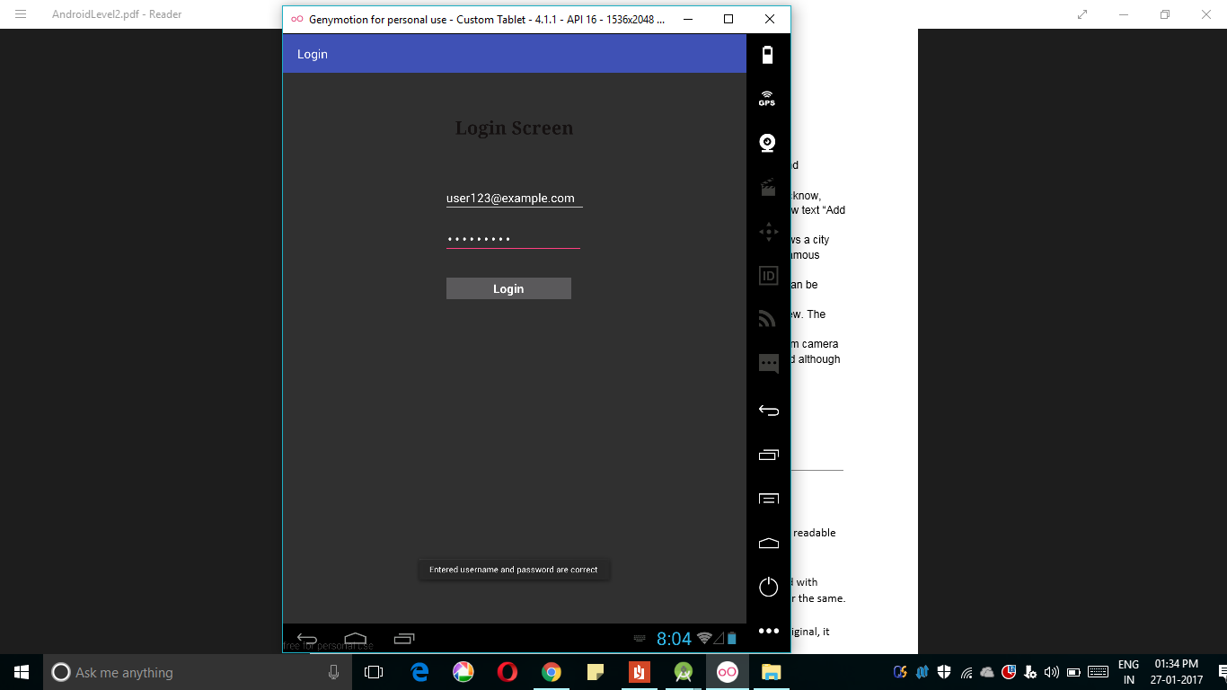

Output when Entering wrong credentials

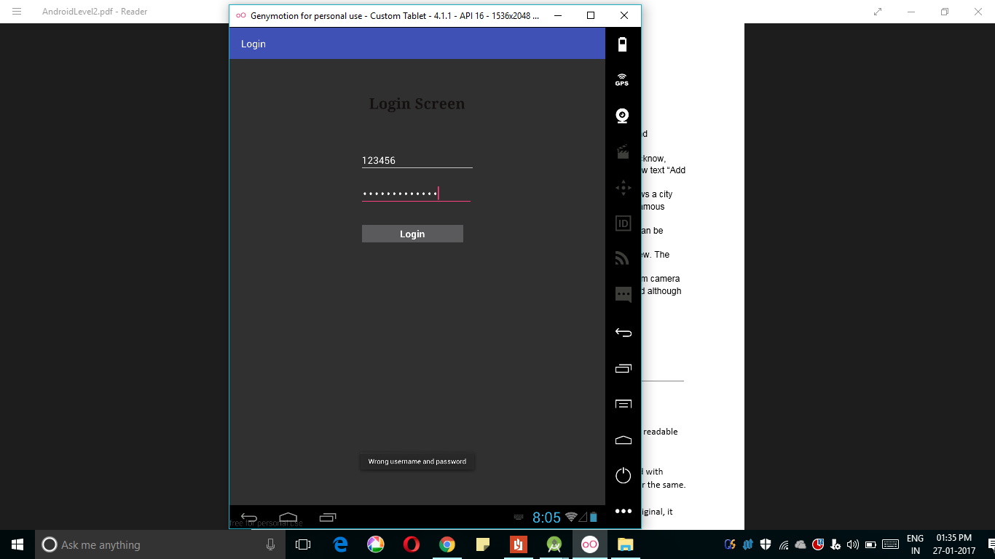

1. Create a screen which will show a grid of 8 cities: Delhi, Mumbai, Ahmedabad, Lucknow, Hyderabad, Bangalore, Chennai, Kolkata. One more grid will show a ‘+’ icon and show text “Add your local place”.

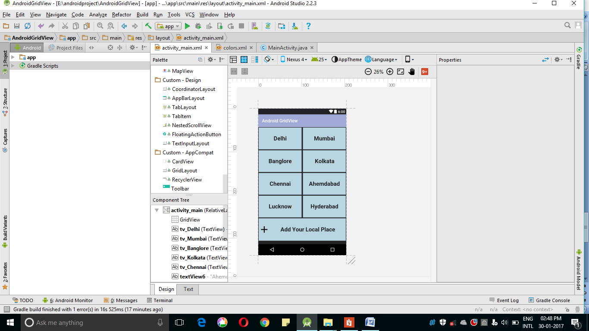

Xml file code

<?xml version="1.0" encoding="utf-8"?>  
<RelativeLayout xmlns:android="http://schemas.android.com/apk/res/android"  
 xmlns:tools="http://schemas.android.com/tools"  
 android:id="@+id/activity_main"  
 android:layout_width="match_parent"  
 android:layout_height="match_parent"  
android:background="@color/colorPrimaryDark"  
 tools:context="com.edwisor.androidgridview.MainActivity">  
  
  
 <GridView  
 android:layout_width="match_parent"  
 android:layout_height="match_parent"  
 android:layout_centerHorizontal="true"  
 android:layout_alignParentTop="true" />  
  
 <TextView  
 android:layout_width="187dp"  
 android:layout_height="95dp"  
 android:text="Delhi"  
 android:id="@+id/tv_Delhi"  
 android:textStyle="bold"  
 android:gravity="center"  
 android:layout_alignParentLeft="true"  
 android:textSize="25sp"  
 android:background="@color/colorAccent"  
 android:layout_margin="2sp"  
 android:textColor="@color/colorPrimaryDark"  
 />  
  
  
 <TextView  
 android:layout_width="187dp"  
 android:textColor="@color/colorPrimaryDark"  
 android:layout_height="95dp"  
 android:text="Mumbai"  
 android:id="@+id/tv_Mumbai"  
 android:textStyle="bold"  
 android:gravity="center"  
 android:layout_alignParentRight="true"  
 android:textSize="25sp"  
 android:background="@color/colorAccent"  
 android:layout_margin="2sp"  
 />  
  
 <TextView  
 android:layout_width="187dp"  
 android:layout_height="95dp"  
 android:text="Banglore"  
 android:id="@+id/tv_Banglore"  
 android:textStyle="bold"  
 android:gravity="center"  
 android:layout_alignParentLeft="true"  
 android:textSize="25sp"  
 android:textColor="@color/colorPrimaryDark"  
 android:background="@color/colorAccent"  
 android:layout_margin="2sp"  
 android:layout_below="@+id/tv_Delhi"  
 />  
  
 <TextView  
 android:layout_width="187dp"  
 android:layout_height="95dp"  
 android:text="Kolkata"  
 android:textColor="@color/colorPrimaryDark"  
 android:id="@+id/tv_Kolkata"  
 android:textStyle="bold"  
 android:gravity="center"  
 android:layout_alignParentRight="true"  
 android:textSize="25sp"  
 android:background="@color/colorAccent"  
 android:layout_margin="2sp"  
 android:layout_below="@+id/tv_Mumbai"  
 />  
  
  
 <TextView  
 android:textColor="@color/colorPrimaryDark"  
 android:layout_width="187dp"  
 android:layout_height="95dp"  
 android:text="Chennai"  
 android:id="@+id/tv_Chennai"  
 android:textStyle="bold"  
 android:gravity="center"  
 android:layout_alignParentLeft="true"  
 android:textSize="25sp"  
 android:background="@color/colorAccent"  
 android:layout_margin="2sp"  
 android:layout_below="@+id/tv_Banglore"  
 />  
  
 <TextView  
 android:layout_width="185dp"  
 android:layout_height="95dp"  
 android:text="Ahemdabad"  
 android:id="@+id/textView6"  
 android:textStyle="bold"  
 android:textColor="@color/colorPrimaryDark"  
 android:gravity="center"  
 android:layout_alignParentRight="true"  
 android:textSize="25sp"  
 android:background="@color/colorAccent"  
 android:layout_margin="2sp"  
 android:layout_below="@+id/tv_Kolkata" />  
  
  
  
  
 <TextView  
 android:layout_height="95dp"  
 android:text="Lucknow"  
 android:id="@+id/tv_Lucknow"  
 android:textStyle="bold"  
 android:gravity="center"  
 android:layout_alignParentLeft="true"  
 android:textSize="25sp"  
 android:textColor="@color/colorPrimaryDark"  
 android:background="@color/colorAccent"  
 android:layout_margin="2sp"  
 android:layout_below="@+id/tv_Chennai"  
 android:layout_width="187dp" />  
  
 <TextView  
 android:layout_height="95dp"  
 android:text="Hyderabad"  
 android:id="@+id/tv_Hyderabad"  
 android:textStyle="bold"  
 android:gravity="center"  
 android:layout_alignParentRight="true"  
 android:textSize="25sp"  
 android:textColor="@color/colorPrimaryDark"  
 android:background="@color/colorAccent"  
 android:layout_margin="2sp"  
 android:layout_below="@+id/tv_Ahemdabad"  
 android:layout_width="187dp" />  
  
  
   
  
 <TextView  
 android:layout_width="400dp"  
 android:layout_height="98dp"  
 android:text="Add Your Local Place"  
 android:id="@+id/tv_Place"  
 android:textStyle="bold"  
 android:layout_centerInParent="true"  
 android:gravity="center"  
 android:textSize="25sp"  
 android:background="@color/colorAccent"  
 android:layout_margin="2sp"  
 android:textColor="@color/colorPrimaryDark"  
 android:layout_below="@+id/tv_Hyderabad"  
 android:drawableLeft="@drawable/Maths_plus"  
  
 />  
</RelativeLayout>

4. On clicking one of the grid, the apps show a detail page of that city. The page shows a city picture and the details about that city. It also shows two buttons at bottom: gallery, Famous places.

Layout

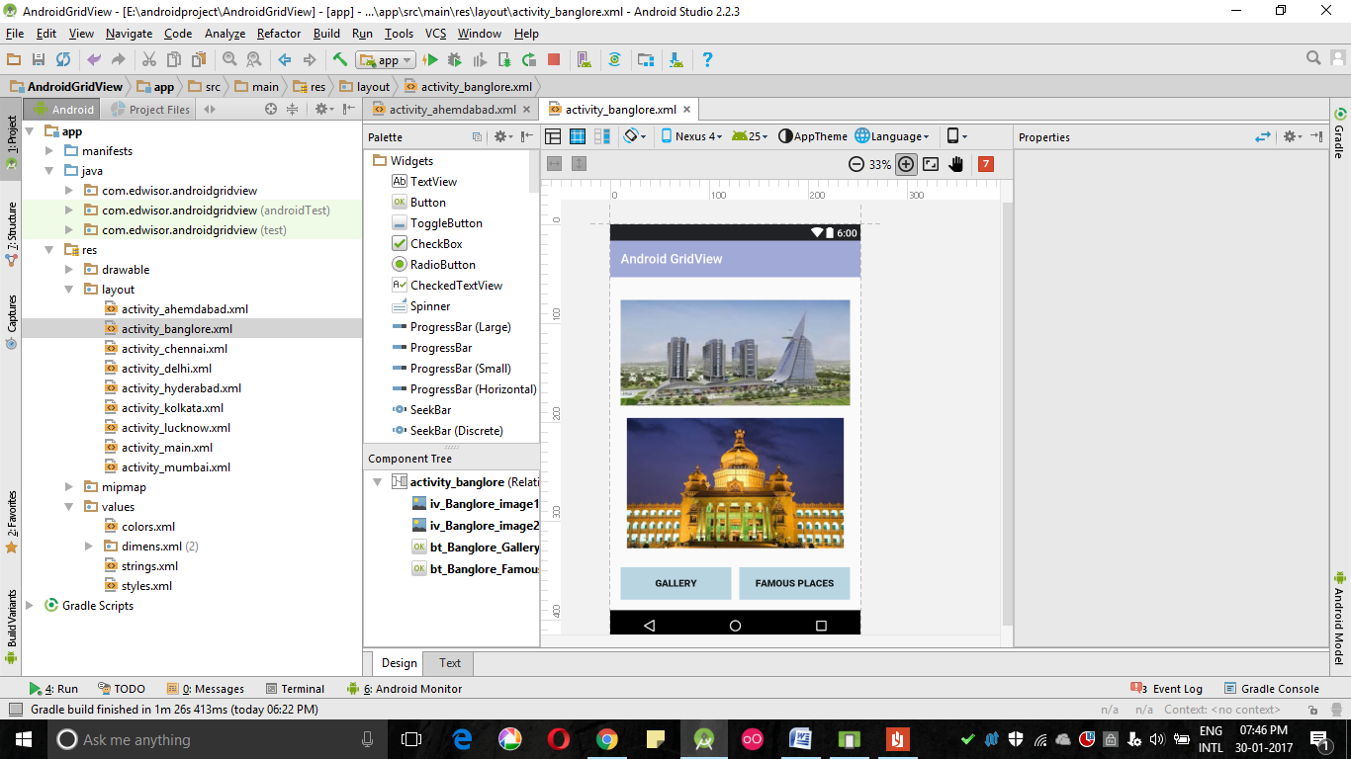

XML File

<?xml version="1.0" encoding="utf-8"?>  
<RelativeLayout xmlns:android="http://schemas.android.com/apk/res/android"  
 xmlns:tools="http://schemas.android.com/tools"  
 android:id="@+id/activity_ahemdabad"  
 android:layout_width="match_parent"  
 android:layout_height="match_parent"  
 android:paddingBottom="@dimen/activity_vertical_margin"  
 android:paddingLeft="@dimen/activity_horizontal_margin"  
 android:paddingRight="@dimen/activity_horizontal_margin"  
 android:paddingTop="@dimen/activity_vertical_margin"  
 tools:context="com.edwisor.androidgridview.Ahemdabad">  
  
 <ImageView  
 android:layout_width="match_parent"  
 android:layout_height="200dp"  
 android:src="@drawable/ahemdabad2"  
 android:id="@+id/iv_Ahemdabad_image1"  
 android:layout_marginBottom="3sp"/>  
  
 <ImageView  
 android:layout_width="match_parent"  
 android:layout_height="200dp"  
 android:layout_below="@+id/iv_Ahemdabad_image1"  
 android:src="@drawable/ahemdabad1"  
 android:id="@+id/iv_Ahemdabad_image2"/>  
  
 <Button  
 android:text="Gallery"  
 android:layout_width="170dp"  
 android:layout_height="50dp"  
 android:layout_alignParentBottom="true"  
 android:id="@+id/bt_Ahemdabad_Gallery"  
 android:textStyle="bold"  
 android:textSize="15dp"  
 android:background="@color/colorAccent"  
 />  
  
 <Button  
 android:background="@color/colorAccent"  
 android:text="Famous Places"  
 android:layout_width="170dp"  
 android:layout_height="50dp"  
 android:layout_alignParentBottom="true"  
 android:layout_alignParentRight="true"  
 android:id="@+id/bt_Ahemdabad_Famous_Places"  
 android:textSize="15dp"  
 android:textStyle="bold"/>  
  
  
  
</RelativeLayout>

JAVA file

package com.edwisor.androidgridview;  
  
import android.content.Intent;  
import android.support.v7.app.AppCompatActivity;  
import android.os.Bundle;  
import android.view.View;  
import android.webkit.WebView;  
import android.widget.GridView;  
import android.widget.TextView;  
  
public class MainActivity extends AppCompatActivity {  
  
 GridView mGridView_Cities;  
 TextView mTv_Delhi, mTv_Banglore, mTv_Mumbai, mTv_Lucknow, mTv_Ahemdabad, mTv_Chennai, mTv_Hyderabad, mTv_Kolkata, mTv_Local_Places;  
  
  
  
  
 @Override  
 protected void onCreate(Bundle savedInstanceState) {  
 super.onCreate(savedInstanceState);  
 setContentView(R.layout.activity_main);  
  
 mTv_Delhi= (TextView) findViewById(R.id.tv_Delhi);  
 mTv_Banglore= (TextView) findViewById(R.id.tv_Banglore);  
 mTv_Mumbai= (TextView) findViewById(R.id.tv_Mumbai);  
 mTv_Lucknow= (TextView) findViewById(R.id.tv_Lucknow);  
 mTv_Ahemdabad= (TextView) findViewById(R.id.tv_Ahemdabad);  
 mTv_Chennai= (TextView) findViewById(R.id.tv_Chennai);  
 mTv_Hyderabad= (TextView) findViewById(R.id.tv_Hyderabad);  
 mTv_Kolkata= (TextView) findViewById(R.id.tv_Kolkata);  
 mTv_Local_Places= (TextView) findViewById(R.id.tv_Local_Place);  
 mGridView_Cities= (GridView) findViewById(R.id.GridView);  
  
  
 mTv_Delhi.setOnClickListener(new View.OnClickListener() {  
 @Override  
 public void onClick(View v) {  
 Intent intent = new Intent(MainActivity.this, Delhi.class);  
 startActivity(intent);  
 }  
 });  
  
 mTv_Banglore.setOnClickListener(new View.OnClickListener() {  
 @Override  
 public void onClick(View v) {  
 Intent intent = new Intent(MainActivity.this, Banglore.class);  
 startActivity(intent);  
 }  
 });  
  
 mTv_Lucknow.setOnClickListener(new View.OnClickListener() {  
 @Override  
 public void onClick(View v) {  
 Intent intent = new Intent(MainActivity.this, Lucknow.class);  
 startActivity(intent);  
 }  
 });  
  
 mTv_Ahemdabad.setOnClickListener(new View.OnClickListener() {  
 @Override  
 public void onClick(View v) {  
 Intent intent = new Intent(MainActivity.this, Ahemdabad.class);  
 startActivity(intent);  
 }  
 });  
  
 mTv_Chennai.setOnClickListener(new View.OnClickListener() {  
 @Override  
 public void onClick(View v) {  
 Intent intent = new Intent(MainActivity.this, Chennai.class);  
 startActivity(intent);  
 }  
 });  
  
 mTv_Hyderabad.setOnClickListener(new View.OnClickListener() {  
 @Override  
 public void onClick(View v) {  
 Intent intent = new Intent(MainActivity.this, Hyderabad.class);  
 startActivity(intent);  
 }  
 });  
  
 mTv_Kolkata.setOnClickListener(new View.OnClickListener() {  
 @Override  
 public void onClick(View v) {  
 Intent intent = new Intent(MainActivity.this, Kolkata.class);  
 startActivity(intent);  
 }  
 });  
  
 mTv_Mumbai.setOnClickListener(new View.OnClickListener() {  
 @Override  
 public void onClick(View v) {  
 Intent intent = new Intent(MainActivity.this, Mumbai.class);  
 startActivity(intent);  
 }  
 });  
  
  
  
 }  
  
  
  
  
  
}

Output

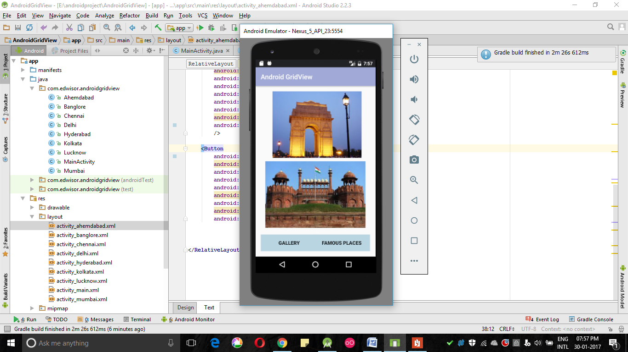

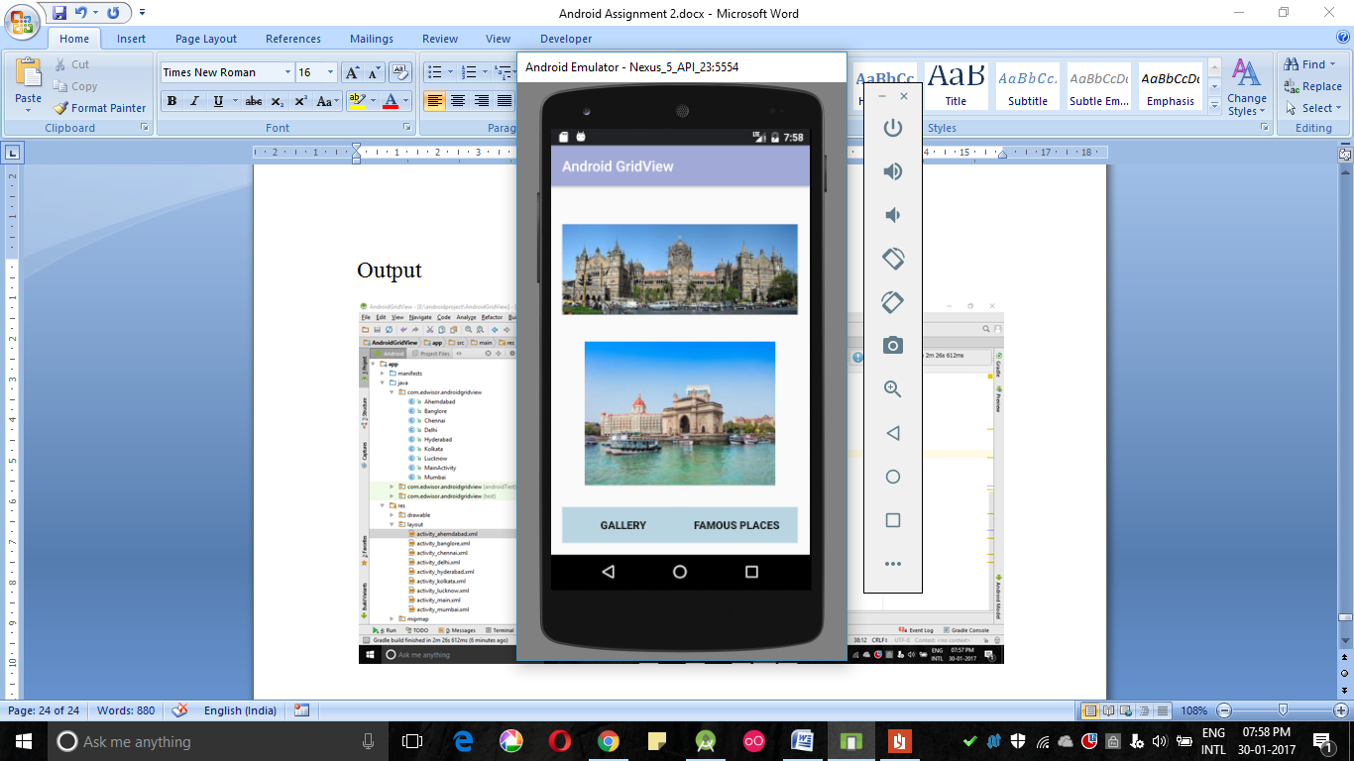

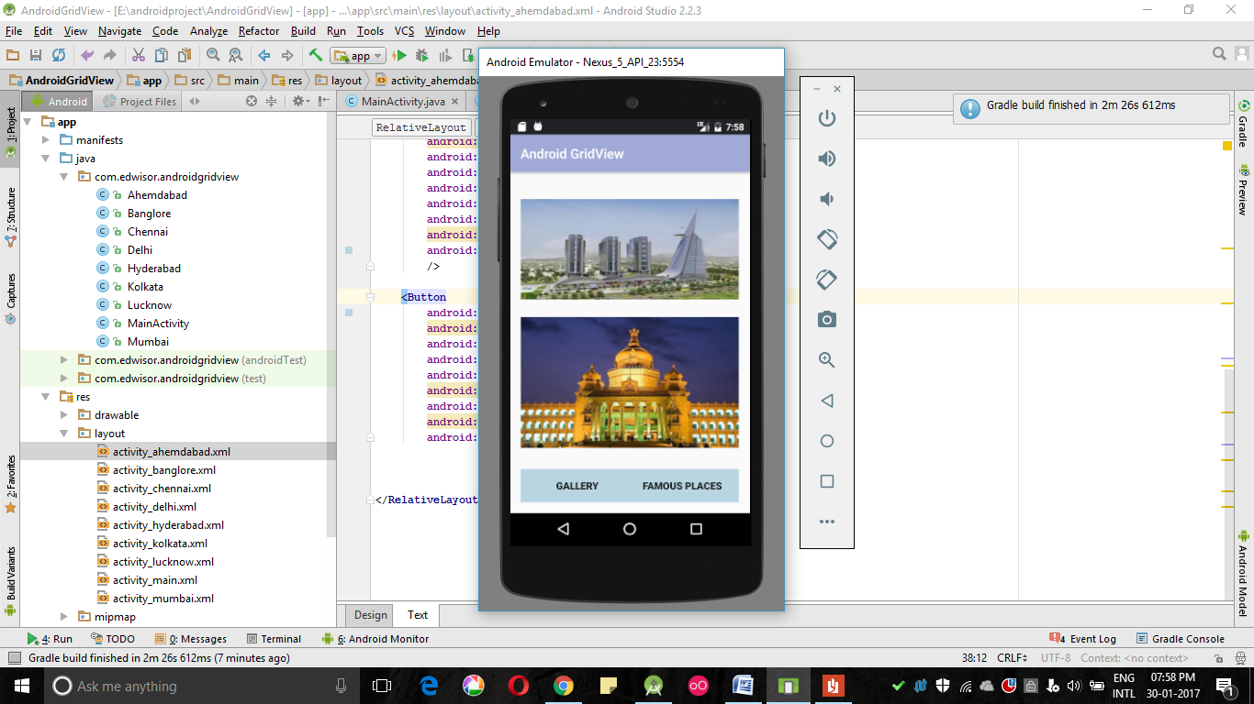

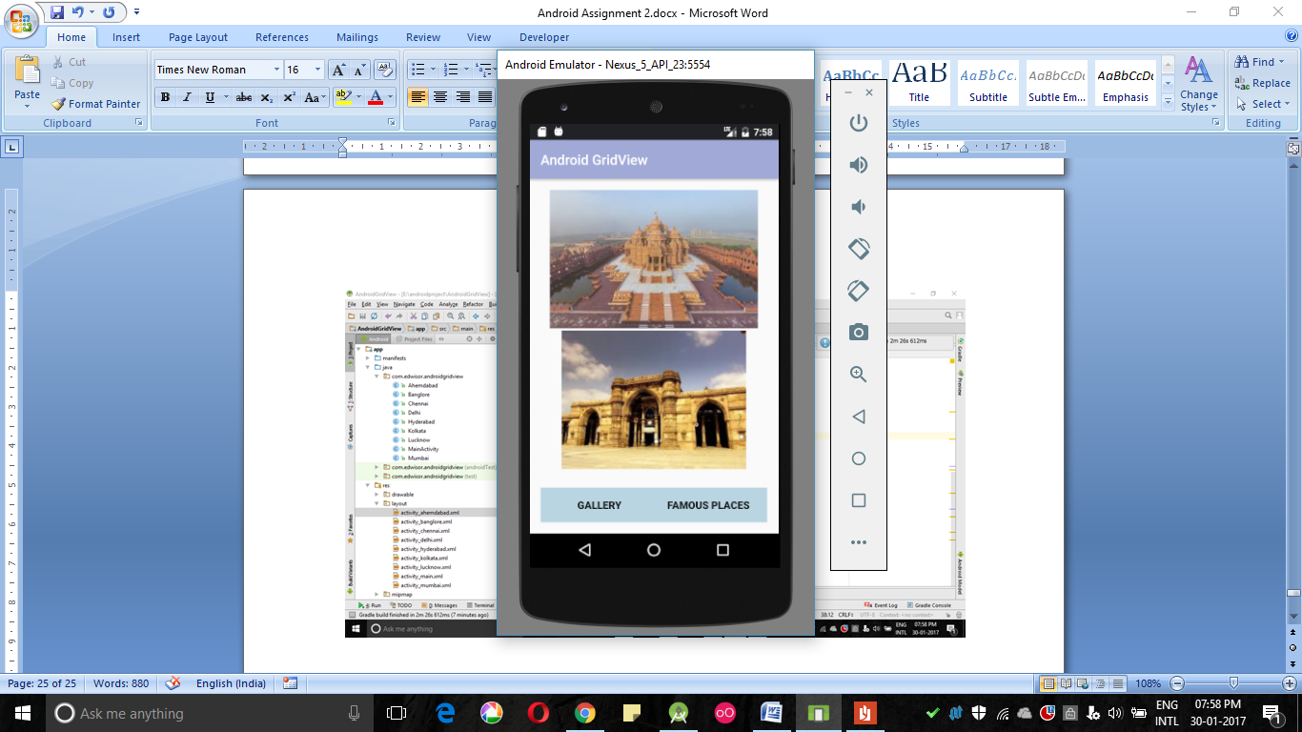

1. On Clicking Gallery, it shows a screen with different pictures of that city. Pictures can be swiped from right to left and left to right.

Xml Code

<?xml version="1.0" encoding="utf-8"?>  
<RelativeLayout xmlns:android="http://schemas.android.com/apk/res/android"  
 xmlns:app="http://schemas.android.com/apk/res-auto"  
 xmlns:tools="http://schemas.android.com/tools"  
 android:layout_width="match_parent"  
 android:layout_height="match_parent"  
 tools:context="com.edwisor.androidgridview.Delhi_ViewFlipper">  
<LinearLayout  
 android:layout_width="fill_parent"  
 android:layout_height="fill_parent">  
  
 <ViewFlipper  
 android:id="@+id/vf_Delhi_Gallery"  
 android:layout_width="fill_parent"  
 android:layout_height="fill_parent"  
 android:layout_centerVertical="true"  
 android:layout_centerHorizontal="true" >  
  
 <ImageView  
 android:layout_width="fill_parent"  
 android:layout_height="fill_parent"  
 app:srcCompat="@drawable/delhi4pg"  
 android:id="@+id/iv_Delhi_Gallery_ViewFlipper_image1" />  
  
 <ImageView  
 android:layout_width="fill_parent"  
 android:layout_height="fill_parent"  
 app:srcCompat="@drawable/delhi3"  
 android:id="@+id/iv_Delhi_Gallery_ViewFlipper_image2" />  
  
 <ImageView  
 android:layout_width="fill_parent"  
 android:layout_height="fill_parent"  
 app:srcCompat="@drawable/delhi7"  
 android:id="@+id/iv_Delhi_Gallery_ViewFlipper_image3" />  
  
 <ImageView  
 android:layout_width="fill_parent"  
 android:layout_height="fill_parent"  
 app:srcCompat="@drawable/delhi5"  
 android:id="@+id/iv_Delhi_Gallery_ViewFlipper_image4" />  
 </ViewFlipper>  
  
</LinearLayout>  
  
  
</RelativeLayout>

Java Code

package com.edwisor.androidgridview;  
  
import android.os.Bundle;  
import android.support.design.widget.FloatingActionButton;  
import android.support.design.widget.Snackbar;  
import android.support.v7.app.AppCompatActivity;  
import android.support.v7.widget.Toolbar;  
import android.view.View;  
import android.widget.ViewFlipper;  
  
public class Delhi_ViewFlipper extends AppCompatActivity implements View.OnClickListener{  
  
 ViewFlipper mDelhi_ViewFlipper;  
  
  
 @Override  
 protected void onCreate(Bundle savedInstanceState) {  
 super.onCreate(savedInstanceState);  
 setContentView(R.layout.activity_delhi__view_flipper);  
  
 mDelhi_ViewFlipper = (ViewFlipper) this.findViewById(R.id.vf_Delhi_Gallery);  
 mDelhi_ViewFlipper.setOnClickListener(this);  
 }  
  
 @Override  
 public void onClick(View v) {  
 mDelhi_ViewFlipper .startFlipping();  
 mDelhi_ViewFlipper.setFlipInterval(3000);  
  
 }

Output

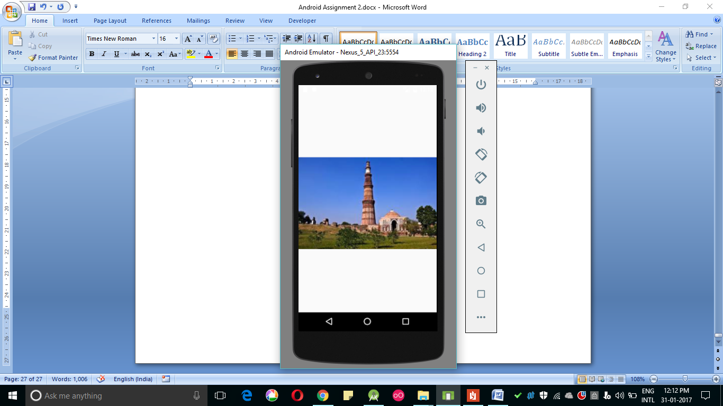

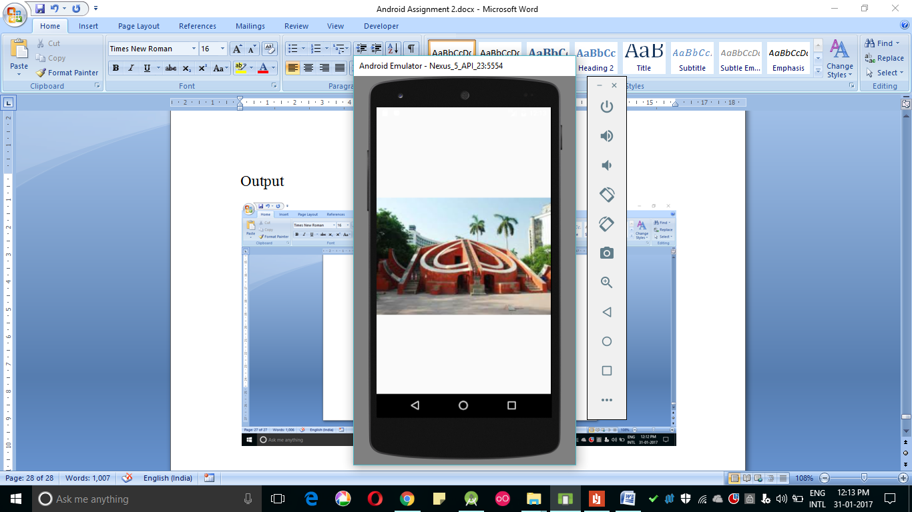

1. On Clicking famous places, it shows a list of all the famous places to visit in ListView. The ListView shows image, title and brief description of the city in CardView.

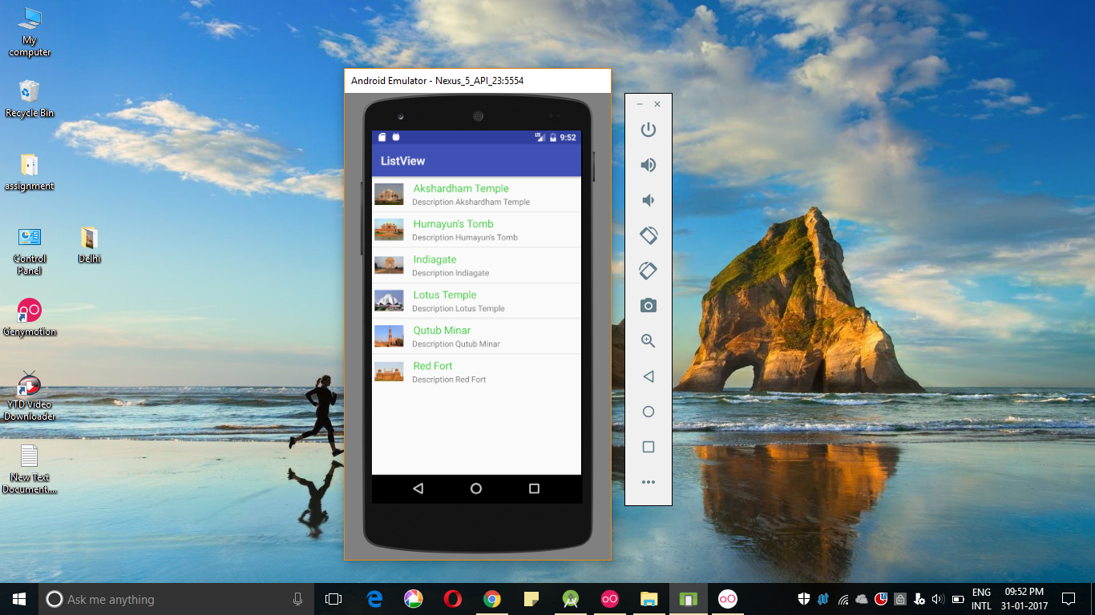

Activity_main.xml

<?xml version="1.0" encoding="utf-8"?>  
<LinearLayout xmlns:android="http://schemas.android.com/apk/res/android"  
 xmlns:tools="http://schemas.android.com/tools"  
 android:layout_width="match_parent"  
 android:layout_height="match_parent"  
 android:orientation="horizontal" >  
 tools:context="com.edwisor.listview.MainActivity">  
  
 <ListView  
 android:id="@+id/list"  
 android:layout_width="match_parent"  
 android:layout_height="wrap_content"  
 android:layout_alignParentLeft="true"  
 android:layout_alignParentTop="true" >  
 </ListView>  
</LinearLayout>

Mylist.xml

<?xml version="1.0" encoding="utf-8"?>  
<LinearLayout xmlns:android="http://schemas.android.com/apk/res/android"  
 android:layout_width="match_parent"  
 android:layout_height="match_parent"  
 android:orientation="horizontal">  
  
 <ImageView  
 android:id="@+id/icon"  
 android:layout_width="60dp"  
 android:layout_height="60dp"  
 android:padding="5dp" />  
  
 <LinearLayout android:layout_width="wrap_content"  
 android:layout_height="wrap_content"  
 android:orientation="vertical">  
  
 <TextView  
 android:id="@+id/item"  
 android:layout_width="wrap_content"  
 android:layout_height="wrap_content"  
 android:text="Medium Text"  
 android:textAppearance="?android:attr/textAppearanceMedium"  
 android:layout_marginLeft="10dp"  
 android:layout_marginTop="5dp"  
 android:padding="2dp"  
 android:textColor="#33CC33" />  
 <TextView  
 android:id="@+id/textView1"  
 android:layout_width="wrap_content"  
 android:layout_height="wrap_content"  
 android:text="TextView"  
 android:layout_marginLeft="10dp"/>  
 </LinearLayout>  
</LinearLayout>

MainActivity.java

package com.edwisor.listview;  
  
import android.support.v7.app.AppCompatActivity;  
import android.os.Bundle;  
  
import android.view.View;  
import android.widget.AdapterView;  
import android.widget.AdapterView.OnItemClickListener;  
  
import android.widget.ListView;  
import android.widget.Toast;  
  
public class MainActivity extends AppCompatActivity {  
 ListView list;  
 String[] itemname ={  
 "Akshardham Temple",  
 "Humayun's Tomb",  
 "Indiagate",  
 "Lotus Temple",  
 "Qutub Minar ",  
 "Red Fort",  
  
 };  
  
 Integer[] imgid={  
 R.drawable.akshardham,  
 R.drawable.humayunstomb,  
 R.drawable.indiagate,  
 R.drawable.lotustemple,  
 R.drawable.qutubminar,  
 R.drawable.redfort, };  
  
 @Override  
 protected void onCreate(Bundle savedInstanceState) {  
 super.onCreate(savedInstanceState);  
 setContentView(R.layout.activity_main);  
  
 CustomListAdapter adapter=new CustomListAdapter(this, itemname, imgid);  
 list=(ListView)findViewById(R.id.list);  
 list.setAdapter(adapter);  
  
 list.setOnItemClickListener(new OnItemClickListener() {  
  
 @Override  
 public void onItemClick(AdapterView<?> parent, View view,  
 int position, long id) {  
   
 String Slecteditem= itemname[+position];  
  
  
 }  
 });  
 }  
}

CustomListAdapter.java

package com.edwisor.listview;  
  
import android.app.Activity;  
import android.view.LayoutInflater;  
import android.view.View;  
import android.view.ViewGroup;  
import android.widget.ArrayAdapter;  
import android.widget.ImageView;  
import android.widget.TextView;  
  
public class CustomListAdapter extends ArrayAdapter<String> {  
 private final Activity context;  
 private final String[] itemname;  
 private final Integer[] imgid;  
  
 public CustomListAdapter(Activity context, String[] itemname, Integer[] imgid) {  
 super(context, R.layout.mylist, itemname);  
   
 this.context=context;  
 this.itemname=itemname;  
 this.imgid=imgid;  
 }  
  
 public View getView(int position,View view,ViewGroup parent) {  
 LayoutInflater inflater=context.getLayoutInflater();  
 View rowView=inflater.inflate(R.layout.mylist, null,true);  
  
 TextView txtTitle = (TextView) rowView.findViewById(R.id.item);  
 ImageView imageView = (ImageView) rowView.findViewById(R.id.icon);  
  
  
 txtTitle.setText(itemname[position]);  
 imageView.setImageResource(imgid[position]);  
  
 return rowView;  
  
  
  
 };  
}

Output



1. Also create add your local place option, where user can add photos by taking it from camera or choosing it from gallery, add description and title. These images need not be saved although the title and description can be saved in preferences.

Xml file

<?xml version="1.0" encoding="utf-8"?>  
<RelativeLayout xmlns:android="http://schemas.android.com/apk/res/android"  
 xmlns:tools="http://schemas.android.com/tools"  
 android:id="@+id/activity_main"  
 android:layout_width="match_parent"  
 android:layout_height="match_parent"  
 android:paddingBottom="@dimen/activity_vertical_margin"  
 android:paddingLeft="@dimen/activity_horizontal_margin"  
 android:paddingRight="@dimen/activity_horizontal_margin"  
 android:paddingTop="@dimen/activity_vertical_margin"  
 tools:context="com.edwisor.camera.MainActivity">  
  
 <Button  
 android:id="@+id/bt_addPlaceGallery"  
 android:layout_width="match_parent"  
 android:layout_height="wrap_content"  
 android:text="From Camera"  
 android:background="@color/colorPrimary"  
 android:layout_alignParentBottom="true"  
 android:layout_alignParentLeft="true"  
 />  
  
  
 <TextView  
 android:layout_width="match_parent"  
 android:layout_height="wrap_content"  
 android:id="@+id/tv_Local_Place_title"  
 android:text="Title"  
 android:textSize="20dp"  
 android:textStyle="bold"  
 android:layout_alignParentTop="true"  
 android:layout_alignParentLeft="true"  
 android:layout_alignParentStart="true"  
 android:layout_marginTop="11dp" />  
  
 <EditText  
 android:layout_width="match_parent"  
 android:layout_height="50dp"  
 android:background="@color/colorPrimary"  
 android:id="@+id/et_Local_Place_Title"  
 android:layout_below="@+id/tv_Local_Place_title"  
 android:layout_alignParentLeft="true"  
 android:layout_alignParentStart="true" />  
  
 <EditText  
 android:layout_width="match_parent"  
 android:layout_height="50dp"  
 android:background="@color/colorPrimary"  
 android:id="@+id/et_Local_Place_Description"  
 android:layout_above="@+id/iv_addLocal"  
 android:layout_alignParentLeft="true"  
 android:layout_alignParentStart="true"  
 android:layout_marginBottom="94dp" />  
  
 <TextView  
 android:layout_width="match_parent"  
 android:layout_height="wrap_content"  
 android:id="@+id/tv_Local_Place_Description"  
 android:text="Description"  
 android:textSize="20dp"  
 android:textStyle="bold"  
 android:layout_above="@+id/et_Local_Place_Description"  
 android:layout_alignParentLeft="true"  
 android:layout_alignParentStart="true" />  
  
 <Button  
 android:text="From Gallery"  
 android:layout_width="match_parent"  
 android:layout_height="wrap_content"  
 android:id="@+id/bt_addPlaceCamera"  
 android:background="@color/colorPrimary"  
 android:layout_above="@+id/bt_addPlaceGallery"  
 android:layout_alignParentLeft="true"  
 android:layout_alignParentStart="true"  
 android:layout_marginBottom="25dp" />  
  
 <ImageView  
 android:id="@+id/iv_addLocal"  
 android:layout_width="match_parent"  
 android:layout_height="63dp"  
 android:src="@drawable/cardeeni"  
 android:layout_marginBottom="14dp"  
 android:layout_above="@+id/bt_addPlaceCamera"  
 android:layout_centerHorizontal="true" />  
  
  
</RelativeLayout>

Java File

package com.edwisor.camera;  
  
import android.content.Intent;  
import android.content.SharedPreferences;  
import android.support.v7.app.AppCompatActivity;  
import android.os.Bundle;  
import android.view.View;  
import android.widget.Button;  
import android.widget.EditText;  
import android.widget.TextView;  
  
public class MainActivity extends AppCompatActivity {  
  
 int PICK_IMAGE = 101;  
 Button mbt_addPlaceGallery, mbt_addPlaceCamera;  
 TextView mtv_Local_Place_title,mtv_Local_Place_Description;  
 EditText met_Local_Place_Title, met_Local_Place_Description;  
 @Override  
 protected void onCreate(Bundle savedInstanceState) {  
 super.onCreate(savedInstanceState);  
 setContentView(R.layout.activity_main);  
  
 mbt_addPlaceGallery = (Button) findViewById(R.id.bt_addPlaceGallery);  
 mbt_addPlaceCamera= (Button) findViewById(R.id.bt_addPlaceCamera);  
 mtv_Local_Place_title = (TextView) findViewById(R.id.tv_Local_Place_title);  
 mtv_Local_Place_Description = (TextView) findViewById(R.id.tv_Local_Place_Description);  
 met_Local_Place_Title = (EditText) findViewById(R.id.et_Local_Place_Description);  
 met_Local_Place_Description = (EditText) findViewById(R.id.et_Local_Place_Description);  
  
 SharedPreferences myPreferences = getSharedPreferences("myPreference", MODE_PRIVATE);  
 myPreferences.edit().putString("Title", "Jaipur").commit();  
 myPreferences.edit().putString("Description", "Jaipur is the capital and largest city of the Indian state of Rajasthan in Northern India.").commit();  
  
 mbt_addPlaceGallery.setOnClickListener(new View.OnClickListener() {  
 @Override  
 public void onClick(View v) {  
 Intent intent = new Intent(MainActivity.this, Blank.class);  
 startActivity(intent);  
  
  
 Intent intent1 = new Intent();  
 intent.setType("image/*");  
 intent1.setAction(Intent.ACTION_GET_CONTENT);  
 startActivityForResult(  
 Intent.createChooser(intent1, "Select Picture"), PICK_IMAGE);  
 }  
 });  
 }  
  
  
 }

Output

